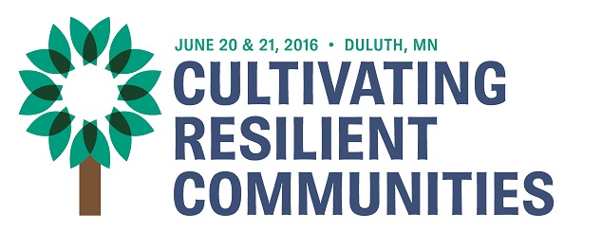
2016 MINNESOTA RURAL HEALTH

INDIVIDUAL/TEAM AWARDS
NOMINATION FORM

Nominations are due May 9, 2016 for the annual Minnesota Rural Health Hero Award, the Minnesota Rural Health Team Award and, new this year, the Rural Health Lifetime Achievement Award. The Lifetime Achievement will be distinguished from the other individual award in length of service and breadth of impact. The Lifetime Achievement Award is meant for individuals who, over the span of their career, have made a lasting or significant contribution to improving rural health. Nominees will have made positive or innovative contributions in the areas of rural health policy, education, legislation, patient care, services, or health care systems within their communities or at a state level.

All the awards recognize outstanding contributions to rural health in our state. They will be presented during the 2016 Minnesota Rural Health Conference Awards Luncheon on June 21 in Duluth.

To nominate a hero, a team or a lifetime achievement recipient, please complete and return this form, keeping in mind the three criteria to be considered by the awards committee:

- What has the individual or team done to contribute to rural health in ways that go “above and beyond”? (10 points)
- How have they demonstrated leadership and vision for rural health? (10 points)
- What impact have their efforts had on rural health? (20 points)

Nominees may have contributed to rural health in any capacity: through a volunteer or paid position, as a health care provider or non-provider, in policy or through practice. Areas of impact could include but are not limited to: health care and health programs, rural health policy, legislation, the advancement of the field, improved patterns of health care delivery, cooperative efforts to avoid duplication of services and achieve common goals, education, and the lasting impact of a program on populations and areas served.

In addition to receiving an award, the rural health hero and the lifetime achievement recipient receives one full conference registration, one hotel room for Monday night, and four awards luncheon passes. The rural health team receives up to four full conference registrations, one hotel room for Monday night, and four awards luncheon passes. Additional luncheon passes may be purchased.

You may include two additional 8 ½ x 11 pages (such as letters of support and/or news articles). No videos or DVDs. All material must be emailed to maria.rogness@state.mn.us by May 9.

If you do not receive an acknowledgment, please call Maria at 651-201-3863.

Nomination for Minnesota Rural Health Award - please check one category:

__Rural Health Hero __Rural Health Team __Lifetime Achievement

Nominee’s Contact Information | Your Contact Information
Nominee Name: | Your Name:
Nominee’s Position: | Your Position:
Nominee’s Work or Volunteer Organization: | Your Organization:
Nominee’s Address: | Your Organization and Address:
Nominee’s Email: | Your E-Mail:
Geographic area affected by nominee’s work: | Your Phone:

Question #1

What has the individual or team done to contribute to rural health in ways that go “above and beyond”? (10 points)

Question #2

How have they demonstrated leadership and vision for rural health? (10 points)

Question #3

What impact have their efforts had on rural health? (20 points)

Question #4

Is there anything else you’d like to share about the nominee – a story, or anything else that would help us appreciate their contributions to rural health?

